Sri Jagadguru Chandrashekhara Bharathi Memorial College, Sringeri


Department of Bachelor of Computer Application
Mobile Application And Development
Evolution and Technical Analysis of a Mobile Application-Udemy

Submitted To,
Soujanya J Lecturer, BCA Department Sri JCBM College,Sringeri

Submitted By,
Sanchana S C
III BCA, Roll No:23184
Sri JCBM College Sringeri

Date:20-03-2026
Place:Sringeri



Lecturer Signature Student Signature

Udemy – Online Learning Platform



Udemy Logo



INDEX

SL.NO. | TOPIC | PAGE NO.
1. | Introduction | 01-04
 | 1.1 Introduction of the Application | 01
 | 1.2 Developer / Company and Year of Launch | 02
 | 1.3 Purpose of the Application | 03
 | 1.4 Type of Application | 04
2. | Initial Features of the Application | 05-06
 | 2.1 Important Features at the Time of First Launch | 05-06
3. | Evolution of the Application | 07-08
 | 3.1 Major Updates Introduced Over the Years | 07
 | 3.2 Improvements in Design and User Interface | 08
4. | Technical Overview | 09-12
 | 4.1 Android Application Components | 09-10
 | 4.2 Intents Used in the Application | 11
 | 4.3 Permissions Required by the Application | 12
5. | Features in the Latest Version | 13
6. | Comparison with Similar Application | 14
7. | Impact on Users or Society | 15
8. | Future Scope | 16
9. | Conclusion | 17
10. | Screenshots | 18-20
11. | References | 21

Chapter 1: Introduction

Introduction of the Application

Udemy is a globally recognized online learning platform that allows users to access thousands of educational courses through the internet. The platform provides opportunities for individuals to learn new skills, improve their professional knowledge, and develop expertise in various fields such as programming, business, design, marketing, photography, and personal development.

With the advancement of mobile technology, Udemy introduced its mobile application so that users can learn conveniently using smartphones and tablets. The mobile app enables learners to watch video lectures, complete assignments, participate in quizzes, and interact with instructors directly from their mobile devices.

The Udemy application supports both Android and iOS operating systems and provides a user-friendly interface that makes it easy for students to browse courses, enroll in classes, and track their learning progress. One of the most important advantages of the Udemy mobile application is the ability to download course videos and study offline without an internet connection.

The application provides thousands of courses created by experts and professionals from different industries. These instructors design structured courses that include video lectures, downloadable resources, practice exercises, and assessments to help learners understand the concepts clearly.
Another key feature of the Udemy application is its personalized recommendation system. Based on the user's interests, previous learning activities, and course searches, the application suggests relevant courses that may help the learner achieve their career goals.

Because of its flexibility, accessibility, and large variety of learning materials, Udemy has become one of the most widely used e-learning applications in the world. The platform plays a significant role in modern digital education by making learning accessible to anyone with a smartphone and internet connection.

Developer / Company and Year of Launch
The Udemy platform was developed by Udemy, Inc., an educational technology company headquartered in San Francisco, California, United States. The company focuses on providing online learning solutions for individuals, businesses, and organizations.
Udemy was founded by three entrepreneurs:

    - Eren Bali
    - Oktay Caglar
    - Gagan Biyani

The idea of creating Udemy originated from Eren Bali’s vision to make education accessible to everyone regardless of their geographical location. Bali grew up in a small village where access to quality education was limited. Through online learning, he realized that technology could remove many barriers to education.

The Udemy platform was officially launched in the year 2010. Initially, it started as a website that allowed instructors to upload and sell their courses online. Later, as smartphones became more popular, Udemy introduced its mobile application to improve accessibility and convenience for learners.

Since its launch, the platform has grown significantly and now hosts thousands of instructors and millions of students from different countries. The company continuously updates its application by adding new features, improving the user interface, and enhancing the learning experience.
Today, Udemy has become one of the largest online learning marketplaces where instructors can create courses and learners can acquire skills in various professional and personal domains.

Purpose of the Application
The main purpose of the Udemy application is to provide an accessible and flexible platform for online learning. It enables users to gain knowledge and develop new skills without the need to attend traditional classroom sessions.
One of the primary objectives of the application is to support self-paced learning. Unlike traditional education systems, where students must follow a fixed schedule, Udemy allows learners to study at their own pace. Users can watch lectures, pause videos, revisit difficult topics, and complete courses according to their convenience.

Another important purpose of the Udemy application is skill development. Many professionals use the platform to learn new technologies and improve their career prospects. For example, students can learn programming languages, digital marketing techniques, graphic design tools, and data analysis skills through Udemy courses.

The application also provides opportunities for instructors and experts to share their knowledge with a global audience. Teachers, industry professionals, and subject experts can create courses and upload them to the platform, allowing learners from different parts of the world to benefit from their expertise.
Additionally, the Udemy application aims to make education more affordable and accessible. Many courses are offered at reasonable prices, and users often receive discounts or promotional offers. This allows students who cannot afford expensive educational programs to still gain valuable knowledge and certifications.

Overall, the purpose of the Udemy application is to create a global learning community where knowledge can be shared easily, skills can be developed efficiently, and learners can achieve their personal and professional goals.

Type of Application
The Udemy application falls under the category of Educational Applications, specifically within the field of E-learning Platforms. E-learning applications are digital platforms that provide educational content through the internet, allowing users to learn remotely using electronic devices.
Udemy can also be classified as an Online Course Marketplace. In this type of platform, instructors create courses and offer them to students who wish to learn specific subjects. The platform acts as a marketplace where learners can browse courses, read reviews, and enroll in programs that match their interests.

Another classification of Udemy is Skill Development Application. Many users utilize the app to develop practical skills that can help them in their professional careers. Courses related to programming, business management, digital marketing, and design are especially popular among students and working professionals.

The application can also be considered a Mobile Learning (m-learning) Application, which means it supports learning through mobile devices such as smartphones and tablets. Mobile learning applications are becoming increasingly popular because they allow users to study anytime and anywhere.
Furthermore, Udemy also functions as a Professional Training Platform for companies and organizations. Businesses use Udemy’s enterprise services to train employees and improve workforce skills.
Because of these multiple functionalities, Udemy is widely recognized as a powerful digital learning platform that combines elements of education, technology, and professional development.

Chapter 2: Initial Features of the Application

Important Features at the Time of First Launch

When the Udemy platform was first launched in 2010 by Udemy, Inc., it introduced several innovative features that made online learning accessible to people across the world. Although the early version of the application was simpler compared to the modern version, it still provided essential tools for both learners and instructors.

The initial features focused mainly on delivering educational content through the internet and enabling instructors to share their knowledge with students globally. These features laid the foundation for the large online learning ecosystem that Udemy has become today.

Online Video Lectures

One of the most important features at the time of Udemy’s launch was the video lecture system. Instructors were able to record and upload video lessons for their courses, and students could watch these lectures through the platform.

Video lectures made learning more interactive and easier to understand compared to traditional text-based materials. Students could pause, rewind, and replay videos to better understand difficult concepts. This feature helped learners study at their own pace and convenience

Course Enrollment System
Another important feature was the course enrollment system. Students could browse through a list of available courses and enroll in the ones they were interested in.
After enrolling in a course, learners were given access to all course materials, including video lectures and downloadable resources. This system allowed students to choose courses based on their personal interests and learning goals.

Instructor Course Creation Tools
Udemy also provided tools for instructors to create and manage their own courses. Teachers and professionals could design structured courses by uploading video lessons, course descriptions, and learning materials.

This feature allowed experts from various industries to share their knowledge with students worldwide. As a result, Udemy quickly became a platform where professionals could teach practical skills and gain recognition as instructors.

Course Categories and Search System
To make it easier for students to find courses, Udemy introduced course categories and search functionality. Courses were organized into categories such as:
- Programming and Technology
- Business and Entrepreneurship
- Personal Development
- Design and Creativity
- Photography and Media

Users could search for specific topics and quickly find relevant courses. This feature improved the user experience by making the platform easy to navigate.

Student–Instructor Interaction
Another important feature was the communication system between students and instructors. Learners could ask questions related to the course content, and instructors could respond to clarify doubts.
This interaction helped create an engaging learning environment where students could receive guidance directly from the course creator.

Downloadable Learning Resources
In addition to video lectures, instructors could provide downloadable resources such as PDFs, presentation slides, and reference materials. These resources helped students review concepts and practice what they learned.
Students could save these materials on their devices and use them for revision even when they were not connected to the internet.

Course Reviews and Ratings
Udemy also included a course review and rating system. Students who completed courses could provide feedback about the instructor, course quality, and learning experience.
This feature helped other users make informed decisions when selecting courses. Highly rated courses became more popular and gained more enrollments.

Basic Progress Tracking
The platform included a basic progress tracking system that allowed students to see how much of a course they had completed. This feature helped learners stay motivated and track their learning progress step by step.

Chapter 3: Evolution of the Application

Major Updates Introduced Over the Years

Since its launch in 2010 by Udemy, Inc., the Udemy application has undergone many updates and improvements to enhance the learning experience for users. As technology advanced and the demand for online education increased, the platform introduced several new features and functionalities.

One of the major updates was the introduction of the mobile application for Android and iOS devices. This allowed users to access courses directly from their smartphones and tablets, making learning more convenient and flexible.

Another significant improvement was the addition of offline video downloading, which allows students to download course lectures and watch them without an internet connection. This feature became very useful for learners who have limited or unstable internet access.
Udemy also introduced course completion certificates, which students receive after successfully completing a course. These certificates can be used to showcase newly acquired skills and improve career opportunities.

In recent years, the platform has also implemented personalized course recommendations based on the user’s learning history and interests. This helps learners discover relevant courses more easily.

These updates have helped Udemy grow into one of the most widely used online learning platforms globally.

Improvements in Design and User Interface
Over time, the design and user interface of the Udemy application have improved significantly. The developers focused on making the application more attractive, simple, and user-friendly for learners.
The modern version of the app features a clean and organized layout that makes it easy for users to browse courses, search topics, and access learning materials. Navigation has become smoother, allowing users to quickly move between course sections and lectures.

Another improvement is the enhanced video player interface, which provides better playback controls such as changing video speed, adding subtitles, and bookmarking important sections.

The application also introduced dark mode and improved color themes, which make the interface more comfortable to use, especially during long learning sessions.

Overall, these design improvements have enhanced the usability of the app and provided a better learning experience for users.

Chapter 4: Technical Overview

Android Application Components

Android applications are built using four main components that help the app function properly. The
Udemy mobile application also uses these components to deliver its services effectively.

Activities

Activities represent the user interface screens of an Android application. Each screen that the user interacts with is considered an activity.

In the Udemy application, examples of activities include:

    - Login and Signup screen
    - Home page showing recommended courses
    - Course details page
    - Video lecture screen

These activities allow users to navigate through the app and interact with its features.

Services

Services are background processes that run without direct user interaction. They perform tasks that need to continue even when the user is not actively using the app.
In the Udemy application, services are used for tasks such as:

    - Downloading course videos for offline viewing
    - Updating course progress in the background
    - Synchronizing user data with the server

These services help ensure that the application runs smoothly and efficiently.

Broadcast Receivers

Broadcast receivers respond to system-wide announcements or events generated by the Android operating system.

For example, the Udemy app may use broadcast receivers to detect:

    - Internet connectivity changes
    - Device battery status
    - System notifications

This allows the app to adjust its functionality based on the device's current state.

Content Providers

Content providers manage and share data between different applications or components within an Android app.

In the Udemy application, content providers can be used to manage data such as:

    - User profile information
    - Course progress data
    - Downloaded course content

They ensure secure and structured access to application data.

Intents Used in the Application Explicit Intent
Explicit intents are used when the application opens a specific activity within the app. In the Udemy application, explicit intents are used to navigate between internal screens such as moving from the course list to the course details page and from the course details page to the video lecture screen. In this case, the application clearly defines the exact activity that should be opened.

Implicit Intent

Implicit intents are used when the application interacts with external applications installed on the device. In the Udemy application, implicit intents are used to open course links in a web browser, share course information through messaging or social media applications, and open email applications for contacting support. These intents allow the application to integrate smoothly with other apps and enhance overall functionality.

Permissions Required by the Application and Their Purpose
Android applications require certain permissions to access device resources and perform specific functions. The Udemy application requests several permissions to provide its services effectively.

Internet Permission

This permission allows the application to access the internet. It is required for:

  - Streaming video lectures
  - Loading course information
  - Updating user progress

Storage Permission

Storage permission allows the app to store data on the device. In Udemy, this permission is used for:
  - Downloading course videos
  - Saving offline learning materials

Network State Permission

This permission allows the app to check the device's internet connectivity status.

It helps the application determine whether it should stream videos online or use downloaded content.

Notification Permission

This permission allows the application to send notifications to users. Examples include:
  - Course updates
  - Promotional offers
  - Learning reminders

Overall, these technical components and permissions enable the Udemy application to deliver a smooth, efficient, and interactive learning experience for its users.

Chapter 5: Features in the Latest Version

5.1 Features Available in the Latest Version of the Application

The latest version of Udemy includes many advanced features that improve the learning experience for users. Over the years, the application has been updated with new technologies and better functionality to support modern digital education.

One of the most important features is offline learning. Users can download course lectures and watch them later without needing an internet connection. This feature is very useful for students who travel frequently or have limited internet access.

Another important feature is high-quality video streaming. The application supports different video resolutions and playback options. Users can also control the playback speed, pause lectures, or replay difficult sections to understand the content better.
The latest version also includes personalized course recommendations. Based on the user’s interests, previously enrolled courses, and learning history, the application suggests new courses that may be useful for the learner.

Udemy also provides course completion certificates. After successfully finishing a course, learners receive a certificate that they can share on professional platforms or include in their resumes.

The app also supports multi-device synchronization, which means users can start learning on one device and continue from the same point on another device.

Additionally, the application includes dark mode, improved search functionality, better course organization, and an enhanced video player interface. These features make the application more user-friendly and efficient for learning.

Chapter 6: Comparison with Similar Application

6.1 Comparison with Another Similar Application

The Udemy application can be compared with Coursera, which is another popular online education platform.

Both applications provide online courses and learning materials for students and professionals. However, there are several differences between the two platforms.

One of the main differences is the type of courses offered. Udemy mainly focuses on practical and skill-based courses such as programming, business skills, digital marketing, and personal development. In contrast, Coursera provides many academic courses developed in partnership with universities and educational institutions.

Another difference is the certification system. Udemy certificates are issued by course instructors or the platform itself, while Coursera certificates are often provided by universities and may have higher academic recognition.

Udemy courses are usually self-paced, allowing students to learn anytime according to their schedule. Coursera sometimes offers structured courses with fixed schedules and deadlines.

The pricing model also differs. Udemy courses are mostly paid but frequently offered at discounted prices, while Coursera provides both free and paid courses, including full degree programs.

Despite these differences, both applications play an important role in promoting online education and helping learners gain valuable skills.

Chapter 7: Impact on Users or Society

Impact of the Application on Users / Society

The Udemy application has had a significant impact on users and society by making education more accessible and flexible. With the rapid growth of digital technology and internet connectivity, online learning platforms like Udemy have changed the way people gain knowledge and develop new skills.

One of the most important impacts of the application is increasing access to education. People from different countries and backgrounds can learn from expert instructors without needing to attend physical classes. This is especially helpful for individuals living in remote areas where access to quality education may be limited.

Another important impact is skill development and career growth. Many students and working professionals use Udemy to learn new technologies, programming languages, business strategies, and creative skills. These courses help individuals improve their qualifications and increase their job opportunities.

The application also supports lifelong learning. Users are not limited by age, location, or educational background. Anyone interested in learning can explore thousands of courses and continuously upgrade their knowledge.
Additionally, Udemy has created opportunities for instructors and professionals to share their knowledge globally. Experts from different industries can create courses and teach millions of learners around the world.

Overall, the Udemy application has played an important role in promoting digital education, improving skill development, and making learning more convenient for people everywhere.

Chapter 8: Future Scope

Possible Future Improvements or Features

Although the Udemy application already provides many advanced features, there are several possibilities for further improvement in the future. As technology continues to evolve, the platform can introduce new tools and innovations to enhance the learning experience.

One possible improvement is the use of Artificial Intelligence (AI) to create personalized learning paths for users. AI systems could analyze a learner’s progress, interests, and performance to recommend courses and study materials that best match their learning goals.

Another future development could be the integration of Virtual Reality (VR) and Augmented Reality (AR) technologies. These technologies could provide immersive learning experiences, especially for subjects that require practical demonstrations or simulations.
Udemy may also improve interactive learning features such as live classes, real-time discussions, and collaborative learning environments where students can interact more actively with instructors and other learners.

Additionally, the platform could introduce advanced assessment tools that evaluate student performance more effectively through quizzes, practical exercises, and skill-based tests.

Another possible improvement is better career guidance features, where the application could recommend learning paths based on job market trends and help users prepare for specific career roles.

In the future, these innovations could make the Udemy application even more powerful and effective as a global learning platform.

Chapter 9: Conclusion

Importance and Success of the Application

The Udemy application has become one of the most successful online learning platforms in the world. Since its launch by Udemy, Inc., the platform has helped millions of learners acquire new knowledge and skills.

Udemy provides a flexible learning environment where users can study anytime and anywhere using their mobile devices. The application offers thousands of courses in different fields such as technology, business, design, marketing, and personal development. This wide variety of courses allows learners to choose subjects that match their interests and career goals.

Over the years, Udemy has continuously improved its features, user interface, and technical capabilities to provide a better learning experience. Features such as offline learning, personalized recommendations, and course completion certificates have made the platform more useful and convenient for users.

The success of the Udemy application demonstrates the growing importance of digital education in modern society. It has helped make learning accessible, affordable, and convenient for people around the world.
In conclusion, Udemy has played a significant role in transforming the way people learn and develop skills in the digital age.

Chapter10:ScreenShots


Udemy Home Screen
- Course Search Page
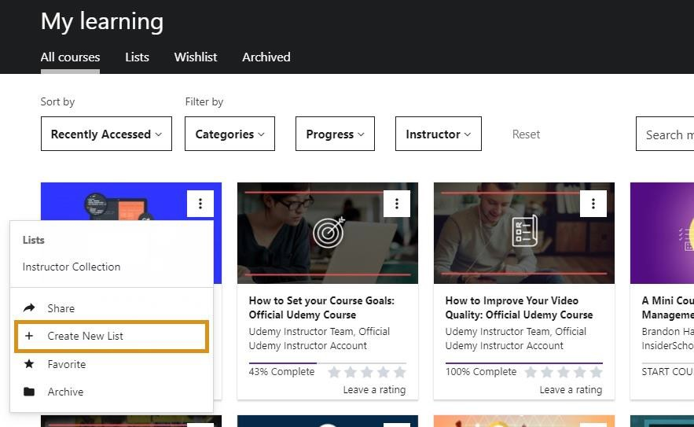

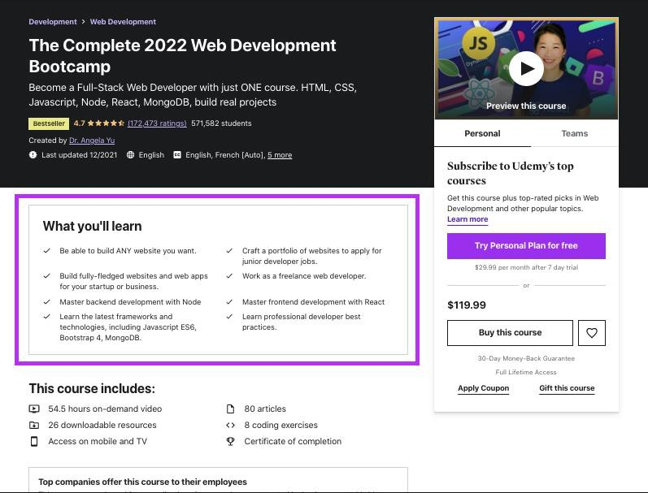
Course Detailed page
- Video Lecture Screen


Course Completion certificate


References
  - Udemy Official Website.
Available at: https://www.udemy.com
  - Udemy, Inc. Company Information. Available at: https://about.udemy.com
  - Mobile Application Development Notes (Class Materials).
  - Coursera Official Website (for comparison study). Available at: https://www.coursera.org
  - Online Articles and Tutorials related to E-learning Applications and Mobile Development.

